TITLE OF FYP (FONT SIZE 16) (NOT BOLD)

By

Student Name
(Reg. #)
Student Name
(Reg. #)

BACHOLAR OF SCIENCE
IN
INFORMATION TECHNOLOGY



DEPARTMENT OF INFORMATION TECHNOLOGY
GOVERNMENT COLLEGE UNIVERSITY, FAISALABAD.
June 2026
DECLARATION

The work reported in this documentation was carried out by me/us under the supervision of [Supervisor Name] Department of Information Technology Government College University, Faisalabad, Pakistan.
I/We hereby declare that the title of project [Project Title] and the contents of the documentation are the product of my own work and no part has been copied from any published source (except the references, standard mathematical or genetic models /equations /formulas/protocols etc.) I/we further declare that this work has not been submitted for award of any other degree /diploma. The University may take action if the information provided is found inaccurate at any stage.

Signature of the Student
[Student Name]
2020-GCUF-xxxxx

Signature of the Student
[Student Name]
2020-GCUF-xxxxx

CERTIFICATE BY SUPERVISORY COMMITTEE

We certify that the contents and form of documentation submitted by Mr. Muhammad Awais Akram Registration No: 2020-GCUF-05215 and by Mr. ATIF AZHAR Registration No: 2020-GCUF-09355. Has been Found satisfactory and in accordance with the prescribed format. We recommend it to be processed for the evaluation by the External Examiner for the award of Degree.

Signature of Supervisor …………………….
Name.……………………………………….
Designation with stamp…………………….

Member of Supervisory Committee
Signature ……………………………………
Name.………………………………….........
Designation with stamp…………………......

Member of Supervisory Committee
Signature ……………………………………
Name.………………………………….........
Designation with stamp…………………......
Chairperson

Signature ……………………………………
Name.………………………………….........
Designation with stamp…………………......

DEDICATED

TO
Write at least one paragraph for dedication Here

ACKNOWLEDGEMENTS
All praise to ALMIGHTY ALLAH, the most merciful and the most compassionate and his Holy Prophet ‘MUHAMMAD’(Peace) be upon him) the most perfect and exalted among and even born on the surface of earth, who is, forever a torch of guidance and knowledge for the humanity as a whole.

[Name of Student 1]
[Name of Student 2]

Table of contents
1. Software requirement specification 1
1.1 Introduction 1
1.2 Stakeholders 1
1.3 Users of the System 1
1.4 Functional Requirements 1
1.4.1 List of Functional Requirements 1
1.4.2 Description of each requirement in Requirement Shell 1
1.5 Non Functional Requirements 1
1.6 Schedule of the Project 1
2. Analysis 2
2.1 Use Case Model 2
2.1.1 Description Of Each Use Case 2
2.2 System Sequence Diagram (SSD) of each use case 2
2.3 Domain Model 2
3. Project Desing 3
3.1 Introduction 4
3.2 Design Class Diagram 4
3.3 Entity Relationship diagram 4
3.4 Sequence Diagram 4
4. implementaion 7
4.1 Code/Algorithm of Main scenarios and Main units of systems 7
5. System testing 8
5.1 Test Case Template 8
6. User Interfaces 9
7. Code IMPLEMENTATION 10

List of Figures
Figure 1: Agile Model 1
Figure 2: Data Flow Diagram 4

List of Tables
Table 1: Manage Users 5
Table 2: Add caption 6

ABSTRACT

CHAPTER 1

Software requirement specification
Write one paragraph.

Introduction
Write few paragraphs related to Introduction.

Stakeholders
Write few paragraphs related to stakeholders.

Users of the System
Write few paragraphs related to Users of the system.

Functional Requirements

List of Functional Requirements

Description of each requirement in Requirement Shell

Non Functional Requirements

Schedule of the Project
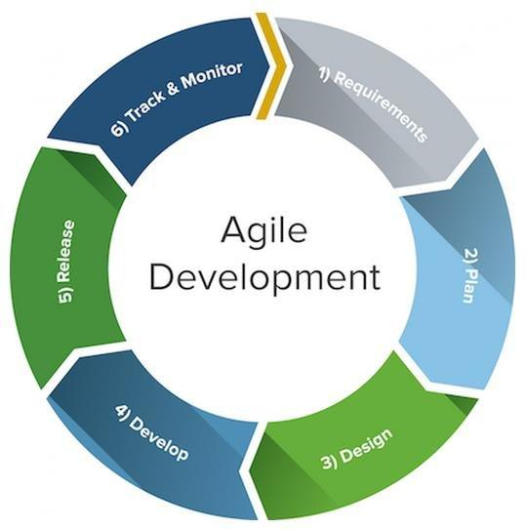
Figure 1: Agile Model
CHAPTER 2

Analysis
This chapter is about the

Use Case Model
The traditional

Description Of Each Use Case
The

System Sequence Diagram (SSD) of each use case

Domain Model

CHAPTER 3

Project Design
This chapter include the project design

Introduction

Design Class Diagram

Entity Relationship diagram

Sequence Diagram
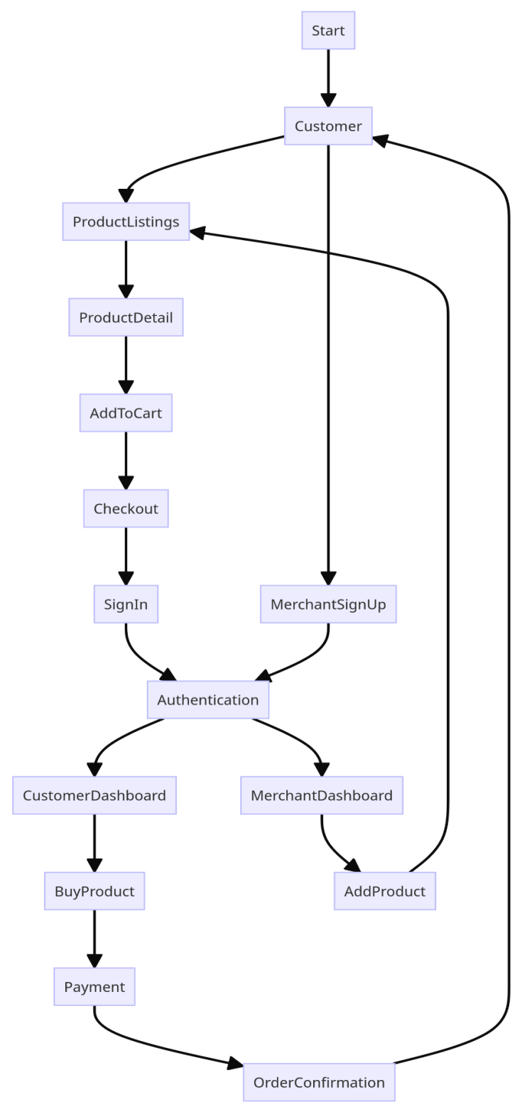
Figure 2: Data Flow Diagram
Requirement Name: Manage Users
Table 1: Manage Users
Requirement #: | Req01 | Requirement Type: | Functional
Description: | This requirement enables users to manage users of the system. Admin can add new users, delete old users and update users info.
Rationale: | To manage users
Originator: | Administrator of the system
Fit Criterion: | User is added in the system. And database is updated.  User is deleted and
Customer Satisfaction: | 5 | Customer Dissatisfaction: | 10
Priority: | 3 | Conflicts: | Nil
Supporting Materials: | NA
History:

(Sample of Fully dressed Format of Use Case)
Use Case Name: Name of the use case (Ref. ………..)
Table 2: Add caption
UC # |  | Ref: | Req. #
UC Name
Level | (Abstract or Detailed)
Description
Actor (s)
Stakeholders
Preconditions
Success Guarantee
Main Success Scenario | Action |  | Response
Main Success Scenario | 1.
Main Success Scenario |  |  | 2.
Extensions
Special requirements
Frequency of Occurrence
Miscellaneous

CHAPTER 4

implementaion
Add details of implementation

Code/Algorithm of Main scenarios and Main units of systems

Chapter 5

System testing

Test Case Template
Test Case #: |  | Test Case Name:
System: |  | Sub System:
Designed By: |  | Design Date:
Executed By: |  | Execution Date:
Short Description:

Pre-Condition:

Operating System: |  |  |  |  |  | Environment:
Software Tools & Technologies with version
Steps | Strategy (Test-to-Pass) / (Test-to-Fail)  (T-T-P) Or (T-T-F) | Action |  | Input | Actual Result / System Response |  | Expected Result/ Expected System Response | Status (Pass/Fail) |  | Remarks
Comments -----------------------------------------------------------------------------------------
---------------------------------------------------------------------------------------------------------------------------------------------------------------------------------------------

Chapter 6

User Interfaces

